**Project 7 Coin Detection with OpenCV**

Name: Forrest Meng Period: 2 Date: 4/13/2020

Did you use OpenCV to detect coins? Yes

What functions/methods from OpenCV did you use?

Imread(), cvtColor(), GaussianBlur(), HoughCircles(), Kmeans()

__________________________________________________________________________________

What functions/methods from OpenCV did you experiment with but ended not using?

N/A

Below do the following:

1. Paste here 2 clear pictures of the initial picture, the picture with the original image and the circles you detected drawn in red (bolded and you may use more colors if you wish).
2. Paste the content of your results.txt file

Coin image 1:

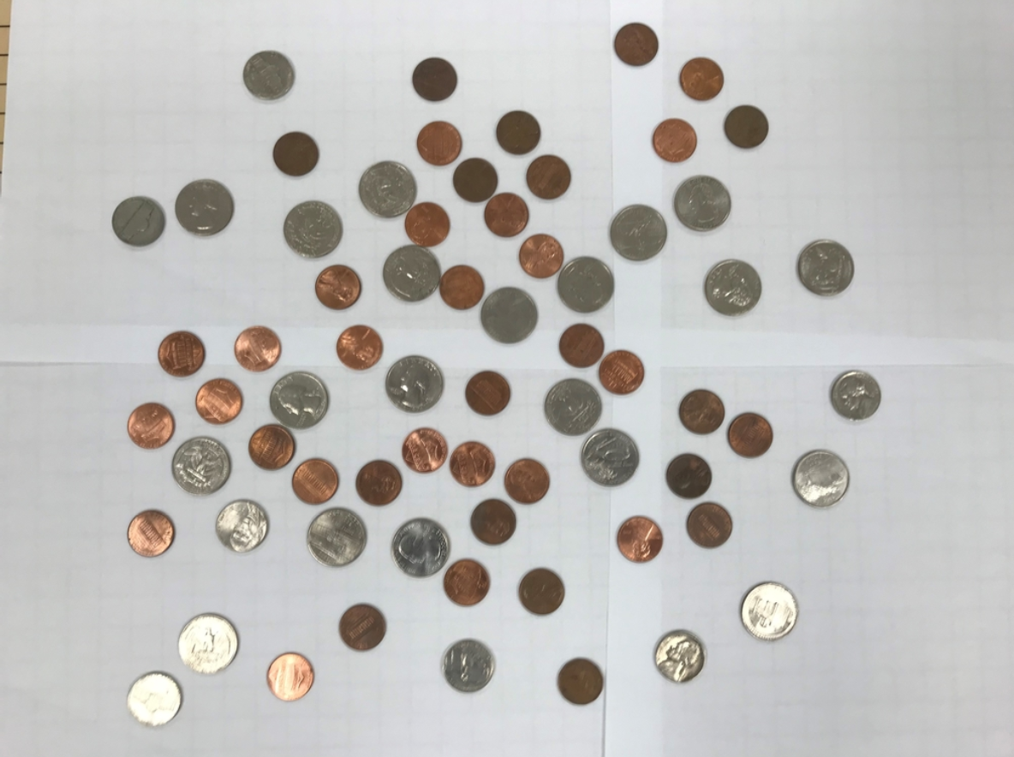

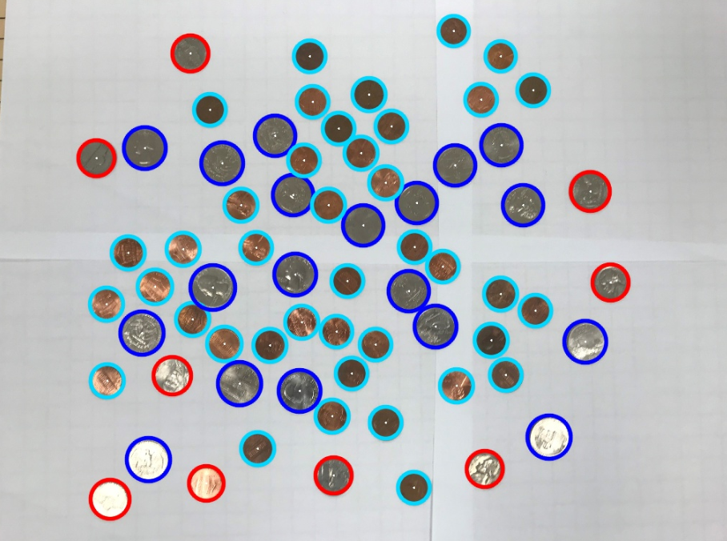

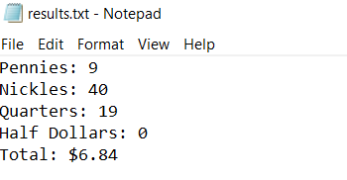

Coin image 2:

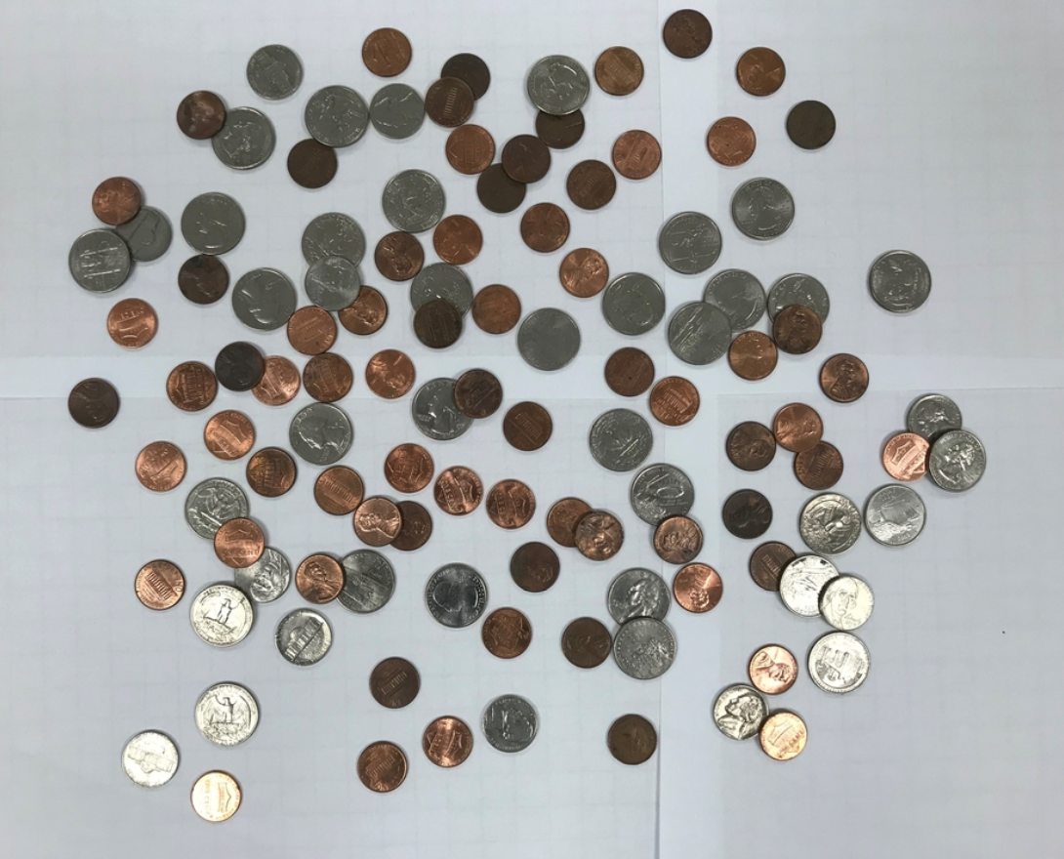

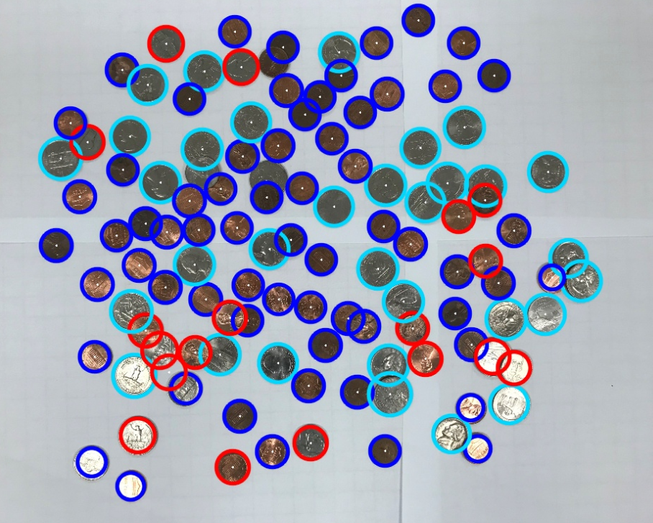

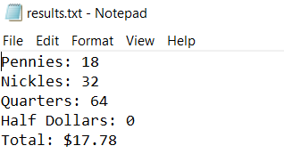

Coin image 3:

